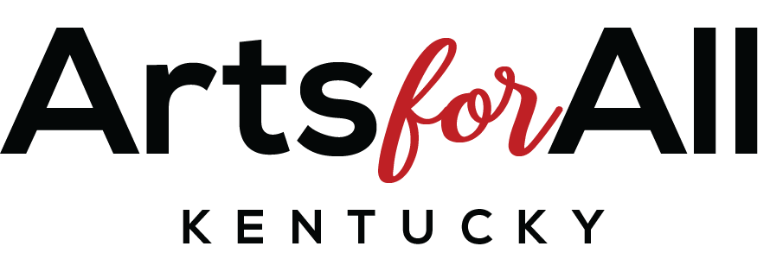

Arts Inclusion Application, Part III
Administrators Signature Page

I have reviewed the application on behalf of:
(Name of School)

and agree to the information included in it for possible funding from Arts for All Kentucky.

If this application is approved for funding by Arts for All Kentucky, I will uphold the budget in this application and honor the narrative description, evaluation plan, and artist agreement herein. An adaptive instructional plan for students with disabilities will be in place for this project to allow full participation of students of all abilities.

I will keep a copy of the Arts Inclusion application for my records to refer to the details proposed and agreed upon, if funded.

If approved, and any changes need to be made (for instance, change of date because of extreme weather), I will contact the Arts for All Kentucky and the artist involved to negotiate that change. Contact Delaire Rowe at programs@artsforallky.org or call 270-792-0023.

I have read and agree to the above. Sign below:

Principal:
Date:

Site Coordinator:
Date:

***This signed form must be included in the application packet (Part I) in order for the application to be reviewed. Please e-mail to programs@artsforallky.org.

