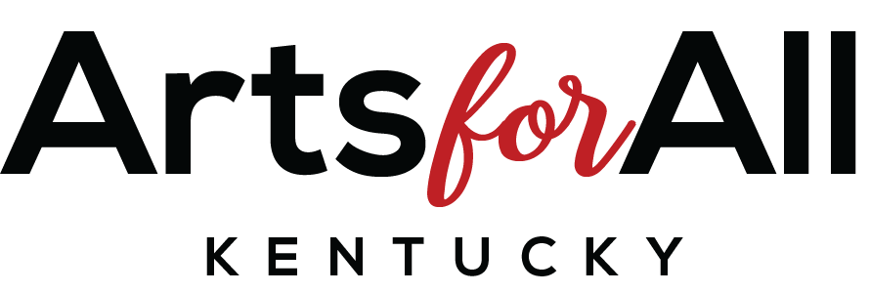
Arts Access/School Program
Final Report

Email report and attachments to programs@artsforallky.org Within 10 days of project completion
*Remaining funds will not be disbursed until this final report is completed.

Questions? Email or call (270) 792-0023.

Section A. Applicant Information

School Name:
County:
School District:
Congressional District # (1-6):
School Address:
City:
Zip:
Phone #:
Principal’s Name:
Site Coordinator’s Name:
Site Coordinator’s E-mail:
Site Coordinator’s Home E-mail:
Site Coordinator’s Cell or Home Phone #:

Section B. Award Profile

- Title of Project or Activity:
- One sentence description of the project or activity:
- Proposed date(s):
- Actual date(s):
- Reason for changing dates:
- Amount of award from Arts for All Kentucky……$1,600
- Amount of cash match by school:
- Amount of in-kind by school:
(Itemize sources and amount.)

- Total Budget for the Project (Add 6, 7 and 8):

10. List key funders other that Arts for All Kentucky (AFA KY):

Section C. Activity

Program Area: (check or highlight all that apply)
- Artist Residency
- Student Performance
- Workshops/Demonstrations
- Exhibition
- Other (Describe):

Discipline: (check or highlight all that apply)
- Visual Arts
- Music
- Dance and movement
- Drama/Theatre
- Media Arts
- Literary Arts
- Storytelling

Program Description:
(Please provide a description of what took place. You may update the program description from your proposal.)

Program Data:
1. Number of students who directly participated in the project:

2. Number of students with disabilities who directly participated in the project:
*(Students with disabilities are students who have an IEP or a 504 plan.)

3. Number of low-income students participating:
*(Students who receive Free and Reduced Priced Meals.)

4. Number of English learners (ELs) participating:
*(ELs are students who receive Title III services)

5. Number of adults who directly participated:

6. Number of teaching artist who participated:

7. Number of sessions (for example, 2 times per week):

8. Length of each session (for example, 1 hour):

9. Number of contact hours per student:

10. Age group of students served: (check or highlight all that apply)
- 0-3 years
- Pre-school
- Kindergarten
- Grades 1-5
- Grades 6-8
- Grades 9-12

11. Number of Service Providers:
Artists:
Educators:
Teaching Assistants:
Student Teachers:
Volunteers:

Section D. Learning Outcomes and Indicators

- Describe what participants were able to do, know, and understand as a result of the project:

- How did you know that participants learned it? What did success look like?

- What were the results of the learning?

- What were the important successes within your program? Tell us 1-2 success stories (big or small, flashy, or ordinary).

- What were the biggest challenges within the program?

- What were the most educational moments (“Ah!” moments) while conducting your program for you or your students?

- What have been some unanticipated outcomes of the program?

Section E. Project Evaluation

- What evaluation tools were used and how was evaluation data collected and analyzed?

*Include examples for documentation with your final report.

Check or highlight two (2) or more:
- Interviews were recorded and evaluated for themes and trends.
- Student program journals were gathered and evaluated for the establishment of benchmarks to gauge student progress.
- Student portfolios were gathered and evaluated for the establishment of benchmarks to gauge student progress.
- Post-event audience surveys were administered for general participation information.
- Pre and post-tests were administered, and information gathered to measure student progress with respect to program-related skill development.
- Teaching artist activity logs were collected and evaluated with respect to teaching artist’s observations of student growth, skill development or other stated goals.
- Video and photo documentation were gathered, viewed, and evaluated for themes and trends.
- Other, please describe:

- Who was responsible for evaluation of this program?

Section F. Final Budget

 | Applicant Cash Match | AFA KY Funds | In-Kind Match
Artist Fees
Technical/Consultant |  | XXXXXX
Materials/Supplies
Marketing/Promotion
Travel
Sub-totals |  | $1,600.00

Total Project Costs: $
*Add subtotals (cash match, AFA KY and In-Kind)
**Please contact Arts for All Kentucky for changes to the budget in the original agreement.

